Quiz 01 Solution
Q1: Write a C++ program that takes two numbers from user and display their sum, product, quotient, and remainder.
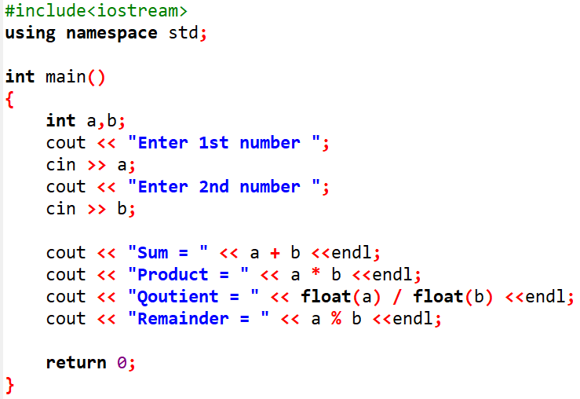
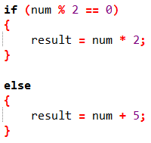
Q2: Convert the C++ if-else code to use a ternary operator.

Solution:
Q3: You are developing a simple console-based program for a retail store's checkout system. The program calculates a discount based on the total purchase amount. If the total is $100 or more, apply a 20% discount. If the total is $50 or more (but less than $100), apply a 10% discount. Otherwise, apply no discount (0%). The program outputs the discount percentage to the customer.
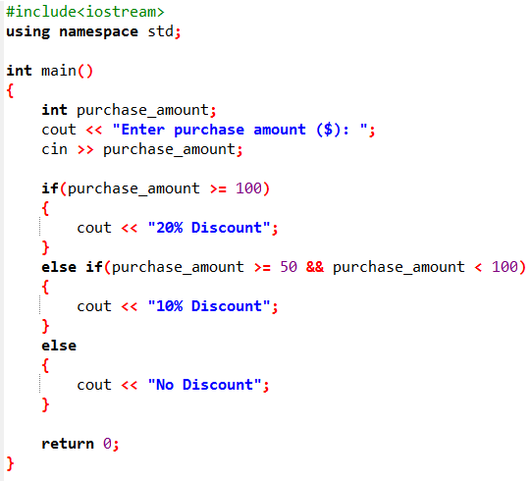
Q4: Identify and write the types of errors occurring in the following code:
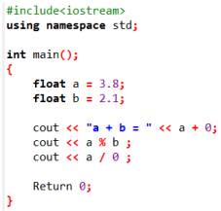
- In line 4 there is semicolon (;) after main() therefore it will generate syntax error.
- In line 9 there will be a logical error because we want sum of a + b but in code it’s written a + 0.
- In line 10 syntax error will occur because remainder cannot be calculated on float values.
- Runtime error will occur in line 11 because division by zero is not possible.
- In line 13 there will be syntax error because R or return is capital.

